**ARTSY MINDS**

**User Manual**

-Varsha Reddy Sripathi

801075913

Table of Contents

1. User of the application
2. Intent of the application
3. Registration
4. Login
5. Connection List
6. Individual Connection
7. New Connection
8. Saved Connections
9. Updating/ Deleting an rsvp
10. Updating/ Deleting a connection
11. Logout
12. About
13. Contact information
14. **User of the application**

* In this application, Users are the people interested in art and craft and would like to connect with people of similar interests.
* Be it art or craft, users can find their kind of people here. They can check out the various groups available and their connections section to look for available events.

1. **Intent of the Application**

* This application acts as a platform for everyone who wish to attend events related to art and craft.
* Users can stay updated about all the events happening in and around the city.

1. **Registration**

* Users can sign into the application from the registration page. Firstly, Click on the ‘Sign Up’ button on the navigation bar and enter the user details and click on Sign Up.
* Users should make sure that valid input is entered into all the input fields.

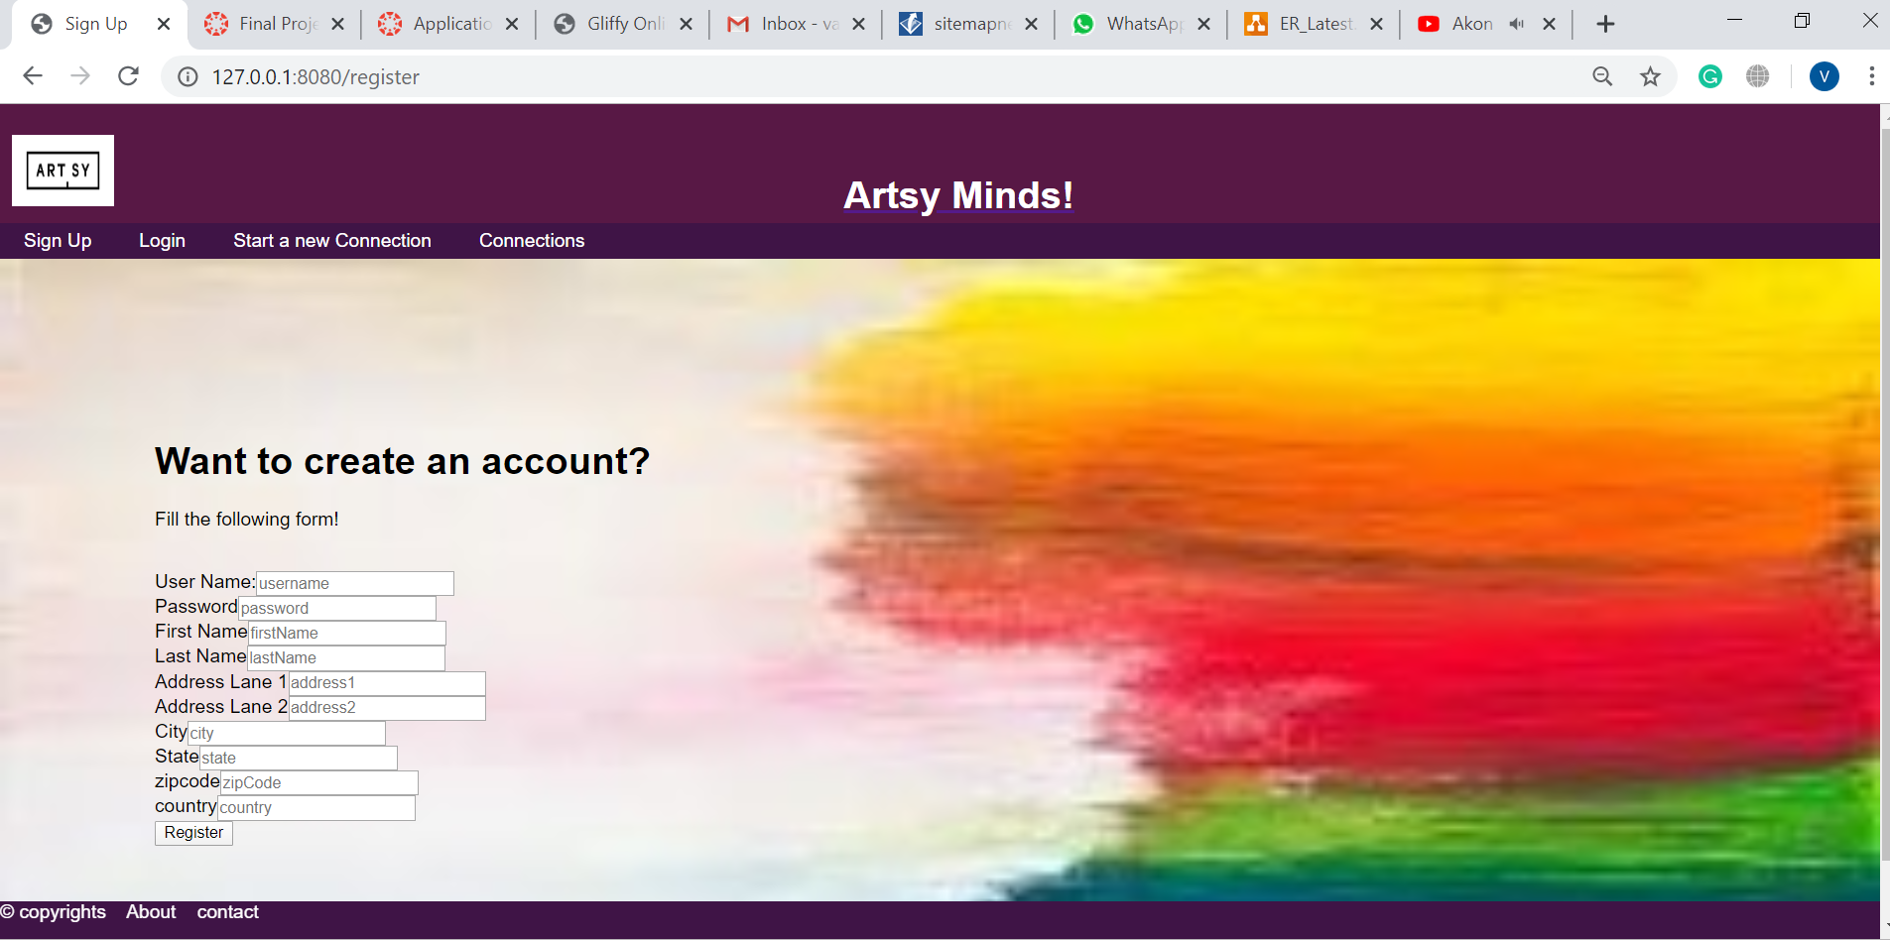

1. **Login**

* All the registered users can sign in the application using their valid Email ID and password by clicking on the ‘Login’ button on the navigation bar.
* Unregistered users need to sign up to be able to login.

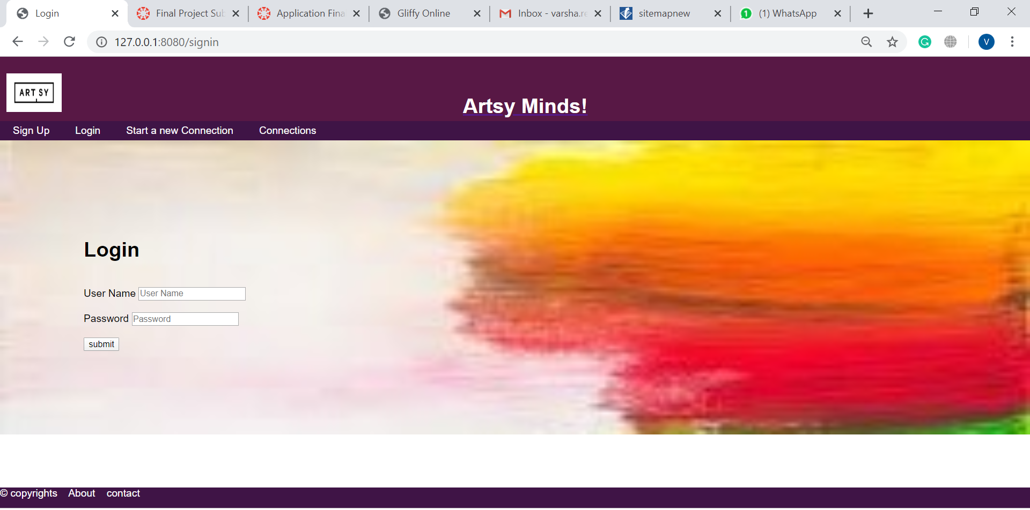

1. **Connections list**

* When we click on the ‘connections’ button on the navigation bar, we get a list of the available connections. Users can see the available connections even if they are logged in or not.

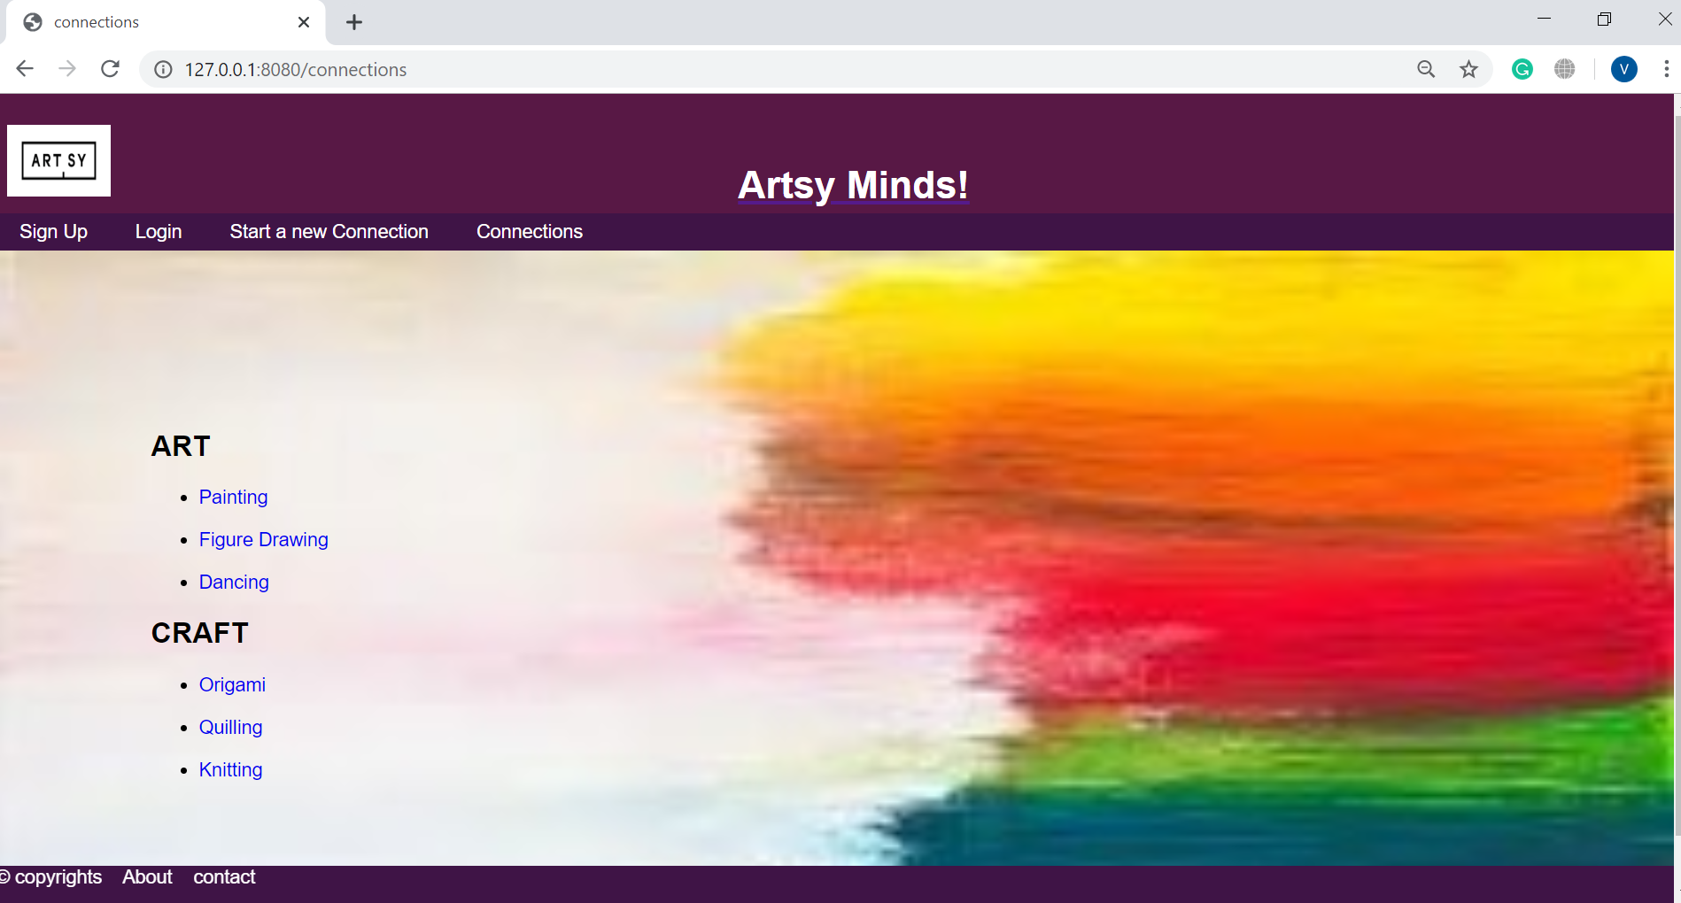

1. **Individual Connection**

* When the user clicks on the name of a connection from the connection list, they can see the details of that particular connection.
* These details include connection name, date, time, location, description of the connection and rsvp.
* Users can rsvp to the event only after logging in.

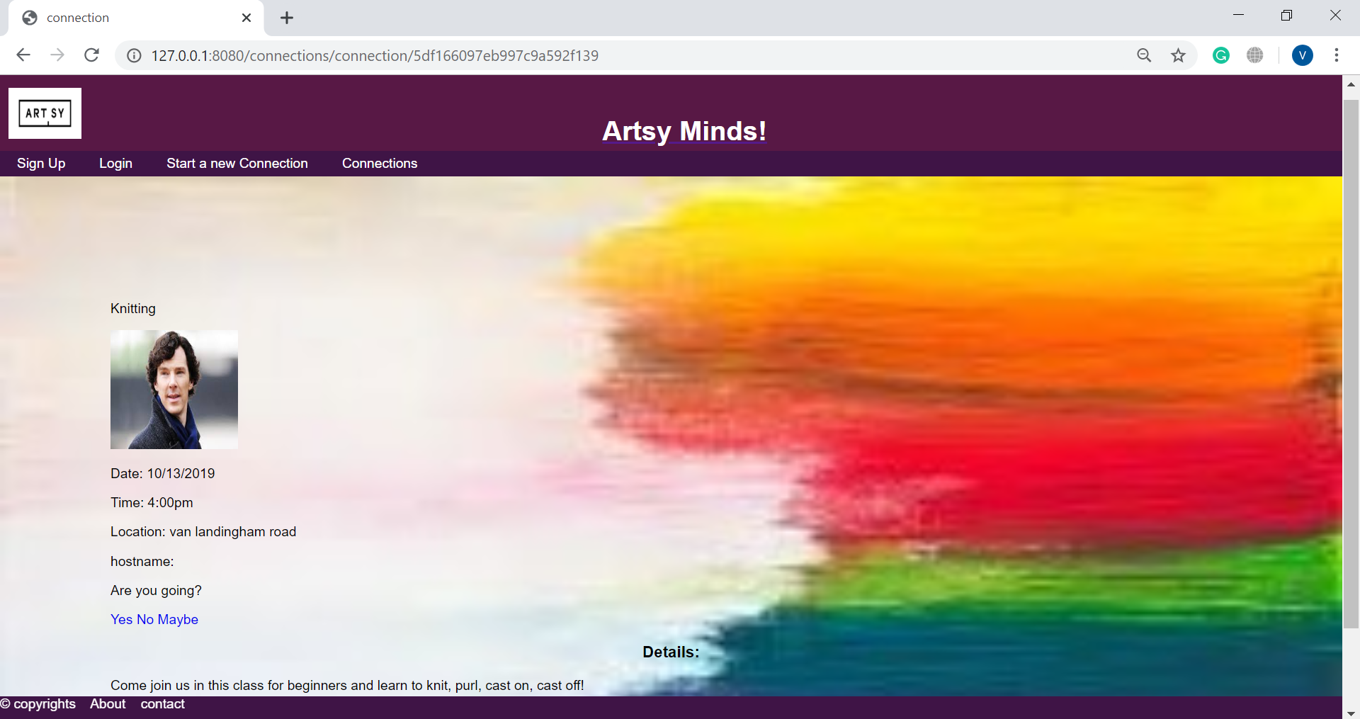

1. **New Connection**

* After logging in Users can add a new connection by clicking on the Start a new connection button on the navigation bar.
* A form will be opened, which can be filled to create a new connection.
* Users should make sure that they enter valid input into all the input fields.

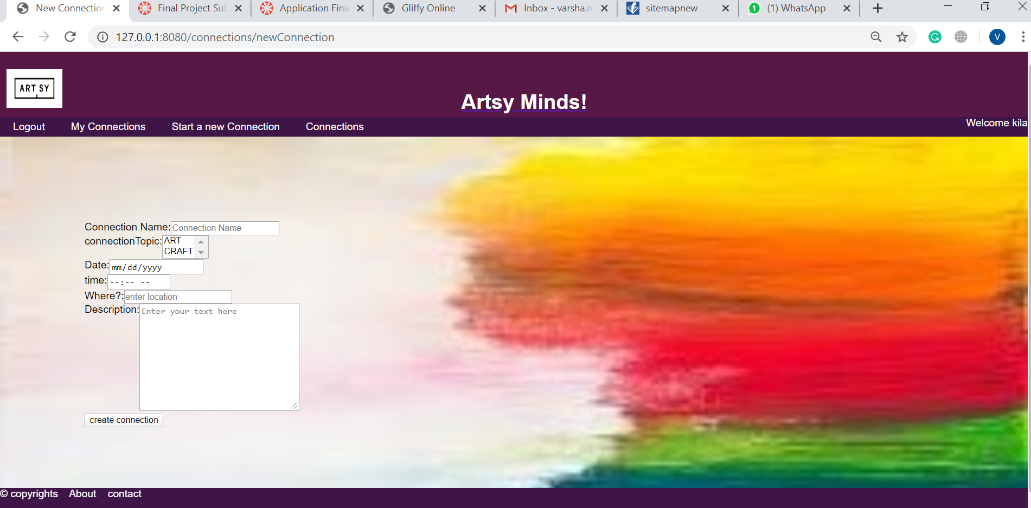

1. **Saved Connections**

* If a user is logged in, they can view their connections by clicking on my connections button on the navigation bar.
* This will show a list of connections which are saved by that particular user.

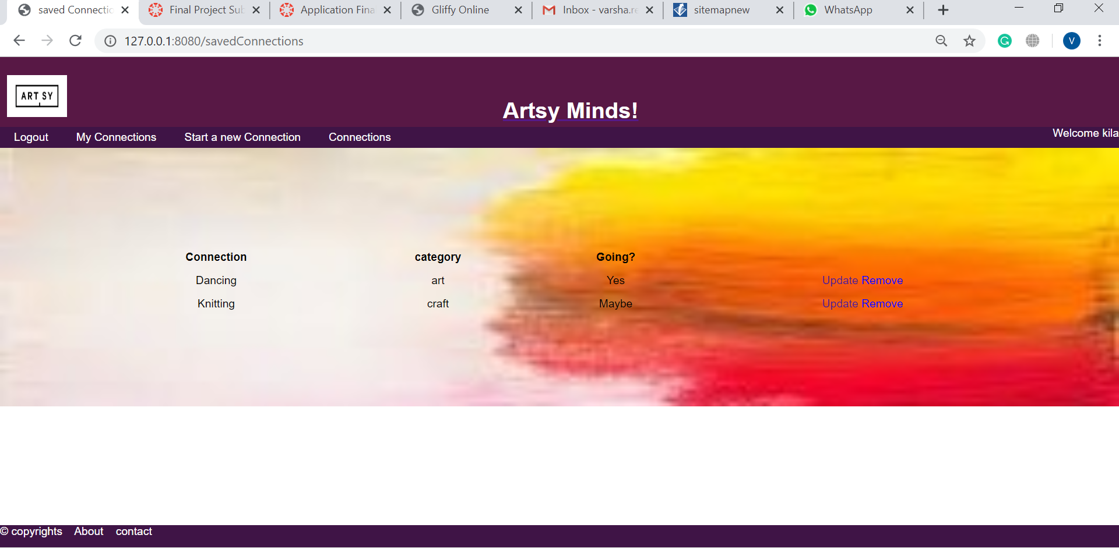

1. **Updating/ Deleting an RSVP**

* When the user clicks on ‘my connections’ button, they can view the saved connection where they can update or delete the rsvp to the connection.
* When they click on update, they can change the rsvp to ‘yes’, ‘no’, or ‘maybe’.
* When they click on delete, they can delete the connection completely from their saved connections.



1. **Updating/ Deleting a connection**

* If the user wishes to update or delete a connection, they can do so by clicking on the ‘update’ or ‘delete’ button in the individual connection page.
* When the user tries to update the connection, they can change the connection details like connection name, time, date, etc.
* When the user tries to delete the connection, the connection get completely deleted.

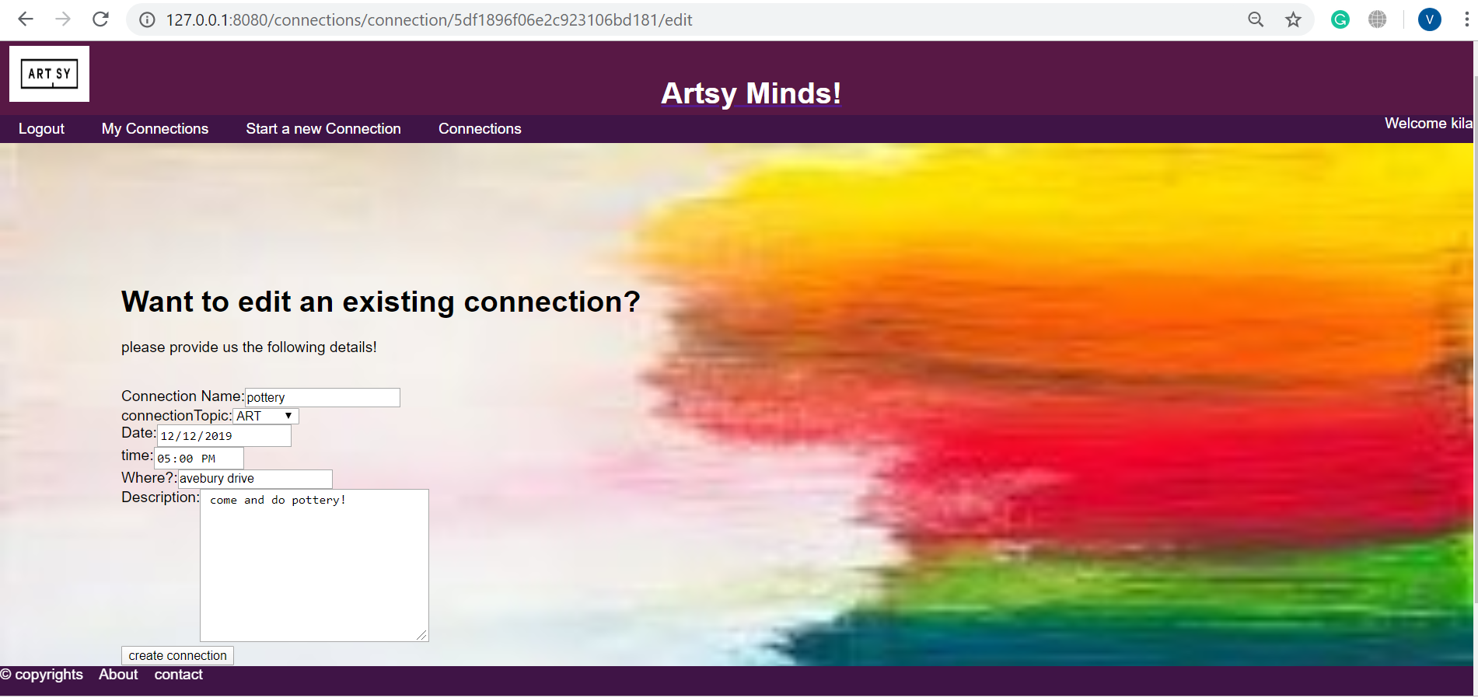

1. **Logout**

* To logout of the account, user can click on the ‘logout’ button on the navigation bar.

1. **About**

* The user can find an about button in the footer. By clicking on it, they can view the details of what the application is about.

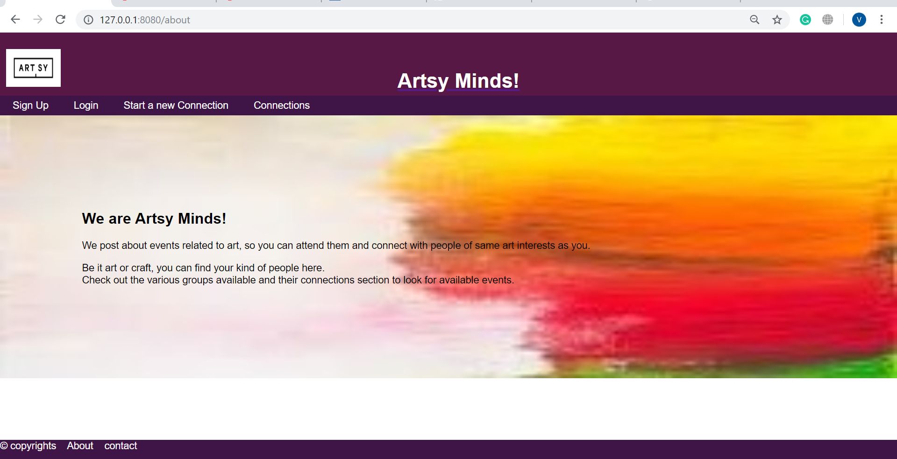

1. **Contact information**

* Contact button can be found in the footer as well. By clicking on it, the user can view the contact information of the application.

.

